**OOP PROJECT**

**PROJECT REP0RT**

**DEPARTMENT OF COMPUTER SCIENCE**

Table of Contents

**OBJECTIVE 2**

FEATURES………………………………………………………………………………………………………………….2

FLOW CHART3-4

CODE5-17

OUTPUT…………………………………………………………………………………………………………17-18

**OBJECTIVE:**

The objective of this OOP (Object-Oriented Programming) project is to implement a basic user management system. This system allows for the following functionalities:

1. **User Registration:**

Allows new users to register by providing a username and password, which are then stored in a list.

1. **User Login:**

Allows registered users to log in by verifying their username and password against the stored data.

1. **Display User List:**

Displays a list of all registered users.

1. **Search User:**

Enables searching for a specific user by username to check if they exist in the system.

1. **Delete User:**

Allows for the deletion of a user from the list based on the username.

**FEATURES:**

Here are the features of this system:

1. **User Registration**:

Users can register by providing a username and password. Upon registration, a new User object is created and added to the list of registered users (vector<User>).

1. **User Login**:

Registered users can log in by providing their username and password. The system checks the provided credentials against the stored user data and allows access if they match.

1. **Display User List**:

The system can display a list of all registered users. This functionality provides an overview of the users currently registered in the system.

1. **Search User**:

Users can be searched for by providing their username. If the user exists in the system, a message indicating their presence is displayed.

1. **Delete User**:

Users can be deleted from the system by providing their username. If a user with the provided username is found, they are removed from the list of registered users.

1. **Menu-Driven Interface**:

The system provides a menu-driven interface for users to interact with various functionalities. Users can choose operations like user registration, login, user list display, user search, user deletion, and program exit through the menu.

1. **Looping Continuity**:

The program continues to execute in a loop until the user decides to exit explicitly. This ensures continuous interaction with the user management system until the user decides otherwise.

Overall, these features collectively provide a basic user management system with functionalities for user registration, login, data display, search, and deletion.

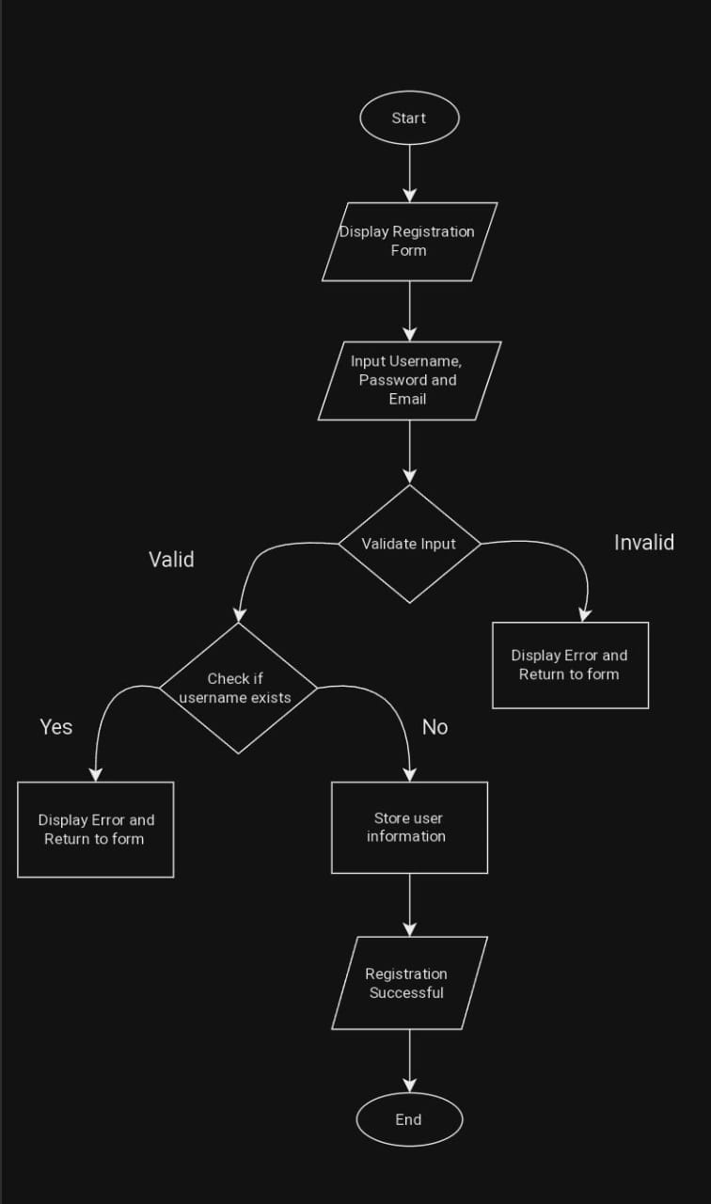**FLOW CHART:**

Registration:

Login form:

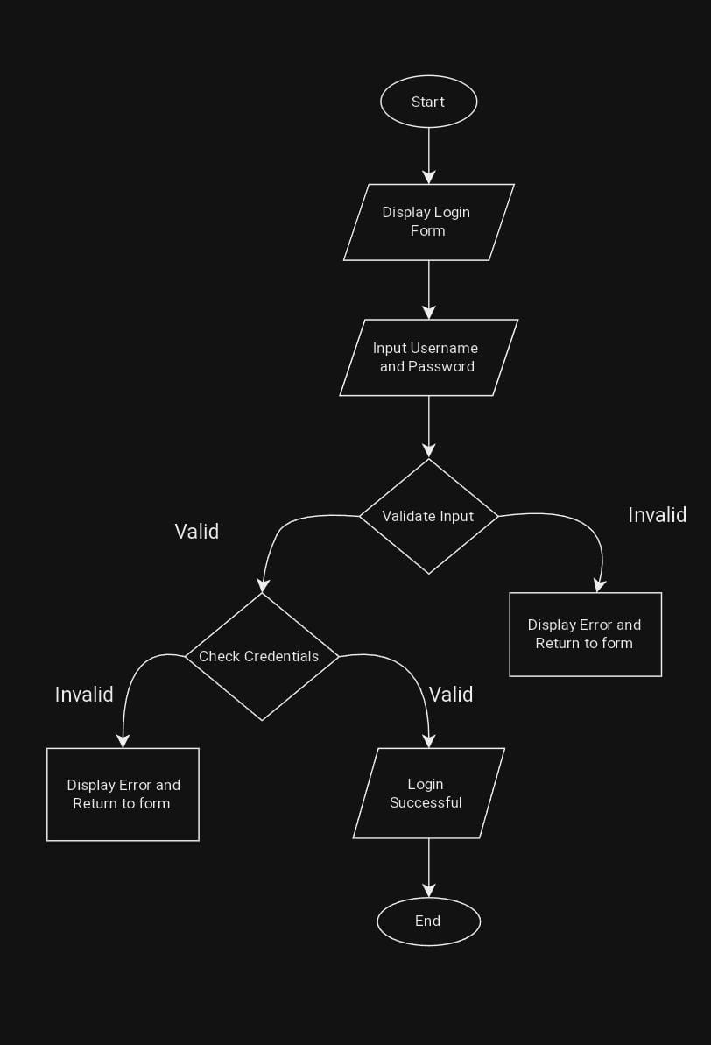

**OUTPUT:**

